**W1D2 Solution**

***Question 1.***

**Algorithm 1**

**Algorithm** findThirdMax(A, n)

**Input** array A of n integers

**Output** third maximum element of A

firstMax ß A[0] // 2

secondMax ß A[0] // 2

thirdMax ß A[0] // 2

indexOfFirstMax ß -1 // 1

indexOfSecondMax ß -1 // 1

for i ß 0 to n do // n

if A[i] > firstMax then // 2n

firstMax ß A[i]; // 2n

indexOfFirstMax ß i; // n

{increment counter i} // 2n

for i ß 0 to n do // n

if i != indexOfFirstMax AND A[i] > secondMax then // 3n

secondMax ß A[i]; // 2n

indexOfSecondMax ß i; // n

{increment counter i} // 2n

for i ß 0 to n do // n

if i != indexOfFirstMax AND i != indexOfSecondMax AND A[i] > thirdMax then // 4n

thirdMax ß A[i]; // 2n

{increment counter i} // 2n

return thirdMax; // 1

**Total // 9 + 26n => O(n) running time**

**Algorithm 2**

**Algorithm** findThirdMax(A, n)

**Input** array A of n integers

**Output** third maximum element of A

max ß A[0] // 2

preMax ß A[0] // 2

prePreMax ß A[0] // 2

indexOfMax ß -1 // 1

indexOfPreMax ß -1 // 1

for i ß 0 to n do // n

if A[i] > max then // 2n

preMax ß max // n

max ß A[i] // 2n

indexOfMax ß i // n

if i != indexOfMax AND A[i] > preMax then // 3n

prePreMax ß preMax // n

preMax ß A[i] // 2n

indexOfPreMax ß i // n

if i != indexOfMax AND i != indexOfPreMax AND A[i] > prePreMax then // 4n

prePreMax ß A[i] // 2n

{increment counter i} // 2n

return prePreMax; // 1

**Total // 9 + 22n => O(n) running time**

**Empirical time comparison**

|  |  |  |
| --- | --- | --- |
|  | **Time in ms** | |
| **Input size** | **Algorithm 1** | **Algorithm 2** |
| 1000 | 1.37 | 0.53 |
| 5000 | 3.44 | 1.53 |
| 10000 | 4.36 | 2.52 |
| 20000 | 6.41 | 6.07 |
| 100000 | 18.61 | 18.37 |
| 1000000 | 44.70 | 38.04 |

**Chart**

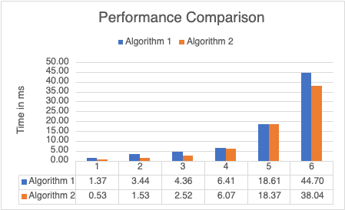

***Question 2.***

|  |  |
| --- | --- |
| 10, 1 | O(1) |
| log(log n) | O(log(log n)) |
| log n, ln n | O(log n) |
| n1/3log n | O(n1/3log n) |
| n1/2log n | O(n1/2log n) |
| n1/k (k > 3) | O(n1/k) |
| n1/3 | O(n1/3) |
| n1/2 | O(n1/2) |
| nlog n, log nn | O(nlog n) |
| n2 | O(n2) |
| n3 | O(n3) |
| nk (k > 3) | O(nk) |
| 2n | O(2n) |
| 3n | O(3n) |
| n! | O(n!) |
| nn | O(nn) |